3d Graphics Programming Project Report

By Toby Cotton

Student Number: A0031189

**Table of Contents:**

**Introduction** -- 3

Software Features -- 3

Software Controls -- 3

**Performance** -- 3

Baseline Test -- 3

Renderer::Render Optimisations -- 4

Future Features -- 5

Improved Baseline Test performance -- 5

**Screenshots** -- 7

**References** -- 11

**Introduction:**

**Software Features:**

I have been following the checklist provided in the ICA. The implementations I have done go as follows:

I have completed all sections in:  
Creating and rendering a cube, Rendering a grided mesh to represent terrain, Rendering a 3D model, Skybox

And some sections in:

Lighting and Shading

* Models / Terrain are shaded correctly using Phong
* Directional lighting is working (using Phong)
* Point lights
* I have also added specular lighting to the program.

**Software Controls**

Left Mouse Button and hold to control character POV(Point of view).

Ctrl to accelerate all processes of movement and POV movement.

W to go forwards.

A to go left.

S to go down.

D to go right.

Spacebar to snap back to initial view

**Performance:**

**Baseline Test:**

Test System:

Gigabyte GeForce RTX 2060 Super 8GB Gaming Video Card

Processor: AMD Ryzen 5 3600 3.6 6 Core processor

Corsair Vengeance LPX 16GB Memory

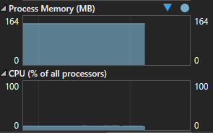

My ram is staying at a steady 132mb usage and a 8% CPU usage.

The break down of this goes as follows:

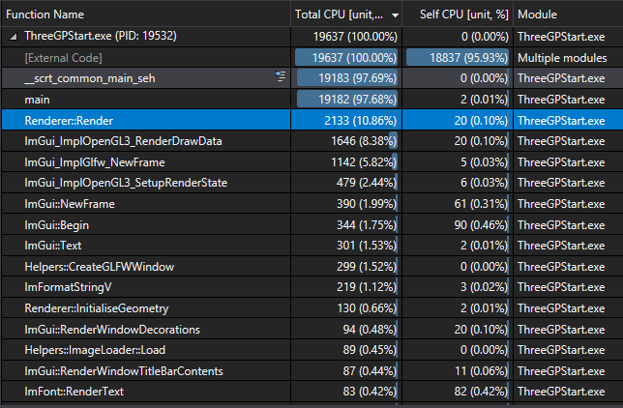

The main the main Redner function functions here that I’ll be focusing on will be:

Renderer::Render – this function is going to be a lot higher than many others due to the fact it is called consistently and is rendering our models.

**Renderer::Render Optimisations:**

So first to optimise this function I have to look at where the main bottlenecks in my code is happening to try and reduce/cutdown cpu and memory usage.

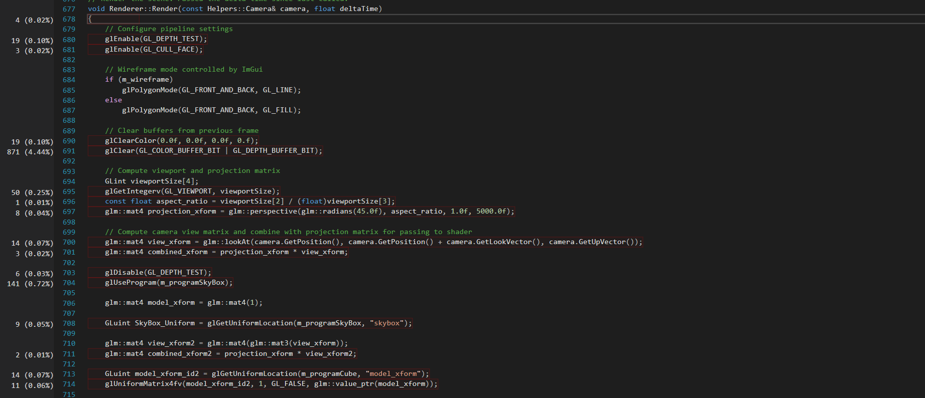

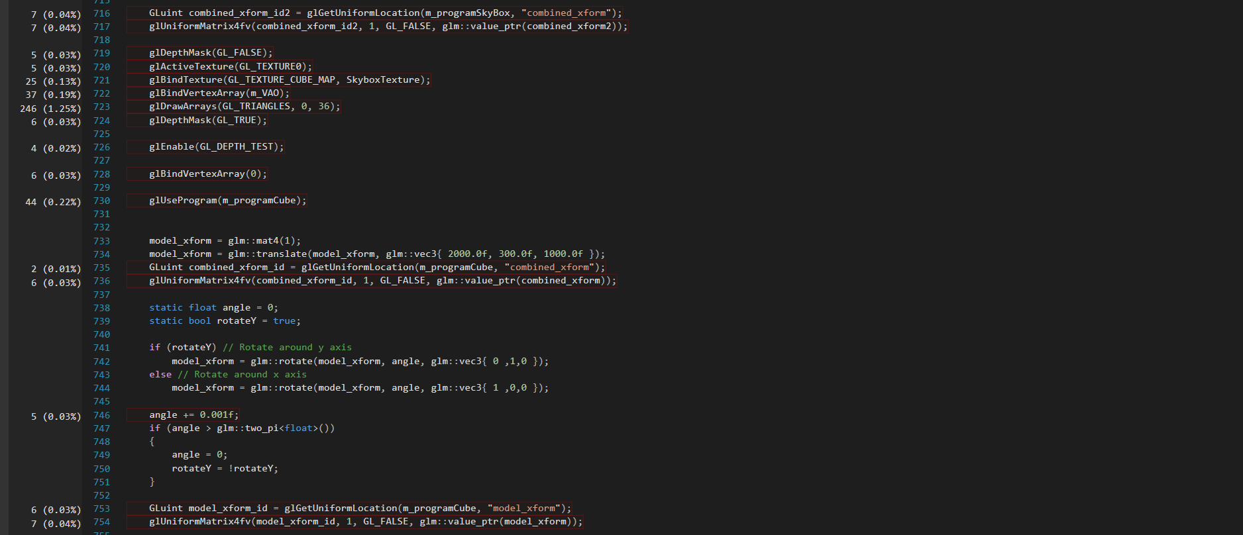

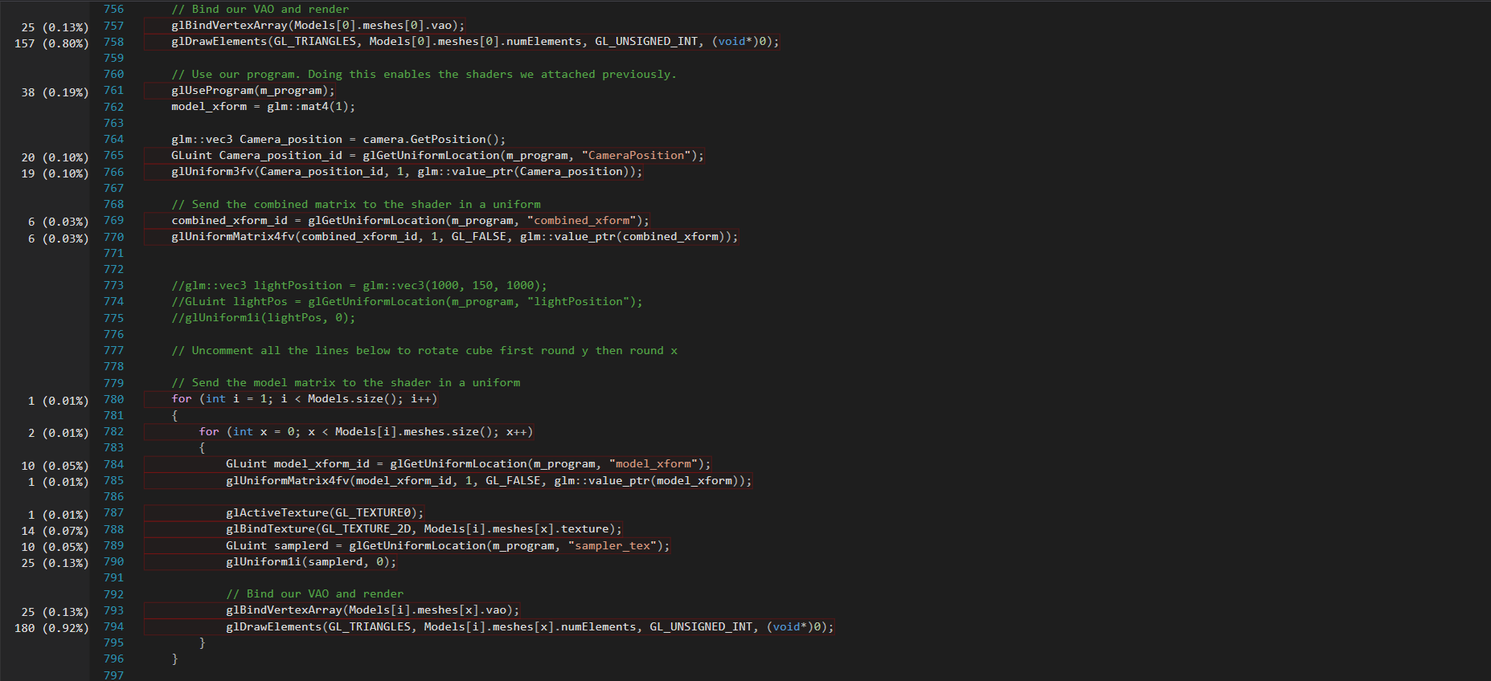

In this code I was able to make 2 major optimisations and 1 minor optimisation which are:

Not enabling Depth Test until after rendering my skybox which has saved : 0.13% in total per run.

Not clearing the screen with a colour as the skybox is already doing this with an image which has saved another:0.1% per run.

Then also taken out a redeclaration of model_xform as between declarations the value does not change.



These changes have made a 0.33% change between the numbers shown and a 344 unit change between the values.

**Memory Usage:**

I have run a Memory Usage platform profiler however many of the sections in which usage has gone up - e.g. the rotation code for the cube – cannot be improved upon.

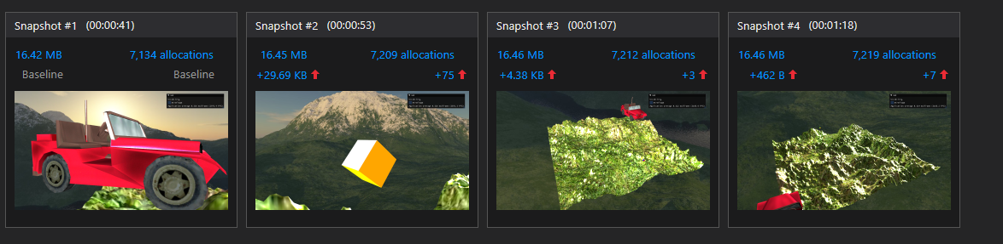

**Future Features:**

**Repetitive texture loading:**

I would like to in the future add repetitive texture loading for things such as grass so that it doesn’t look like one stretched texture but lots of grass textures loaded together.

**Clouds:**

In the future of this program would like to add moving clouds in which move above the user to add more realism to the skybox.

**Improved Baseline Test performance:**

So after inputting the performance improvements I have gone through above.

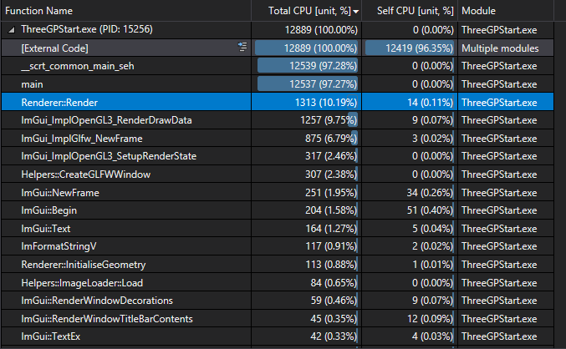

So with all the improvements made in total there is a total CPU difference off 6748 improvement however this could have been affected by the time the window is open.

**Screenshots:**

**Directional lighting:**

To show this I have disabled ambient and my point light.

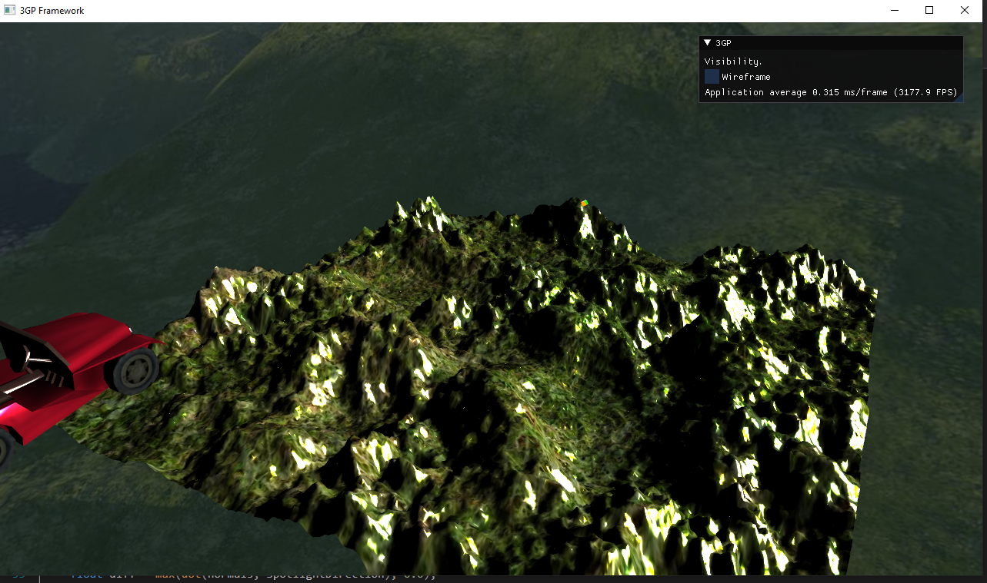

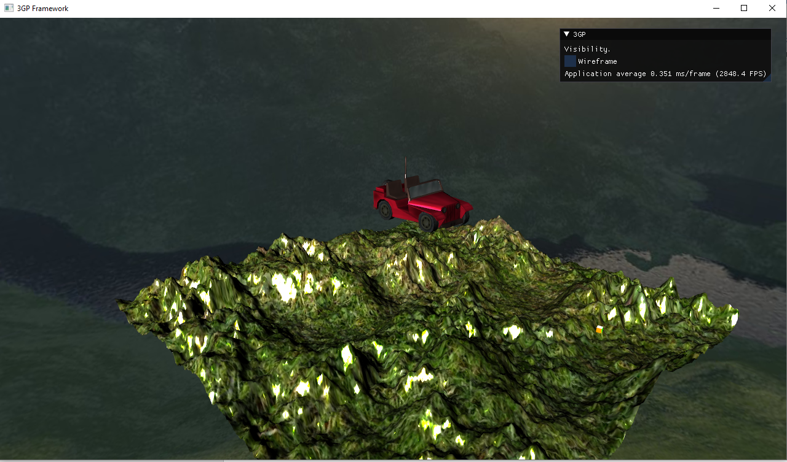

**Point Light**

To show this I have disabled ambient and my directional light.

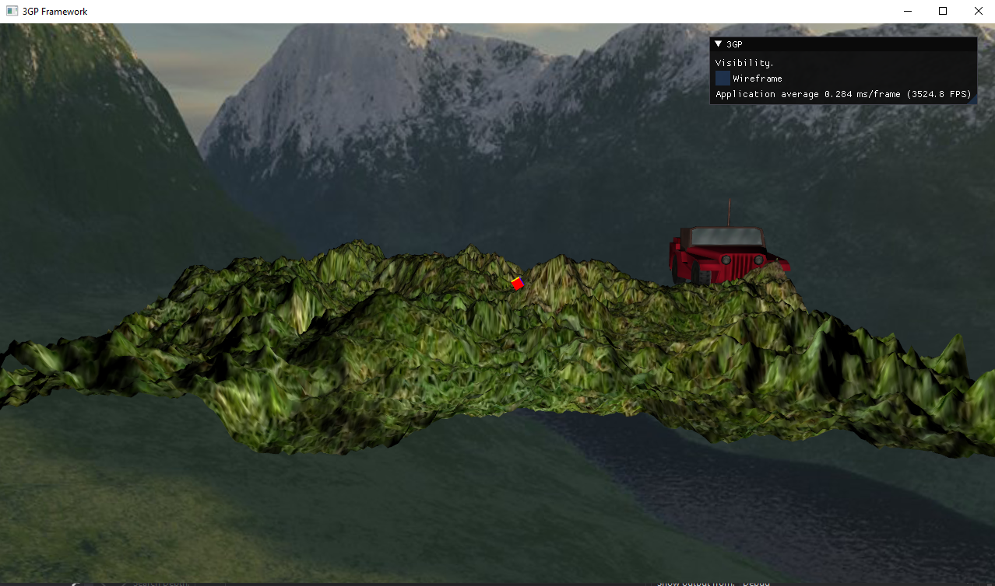

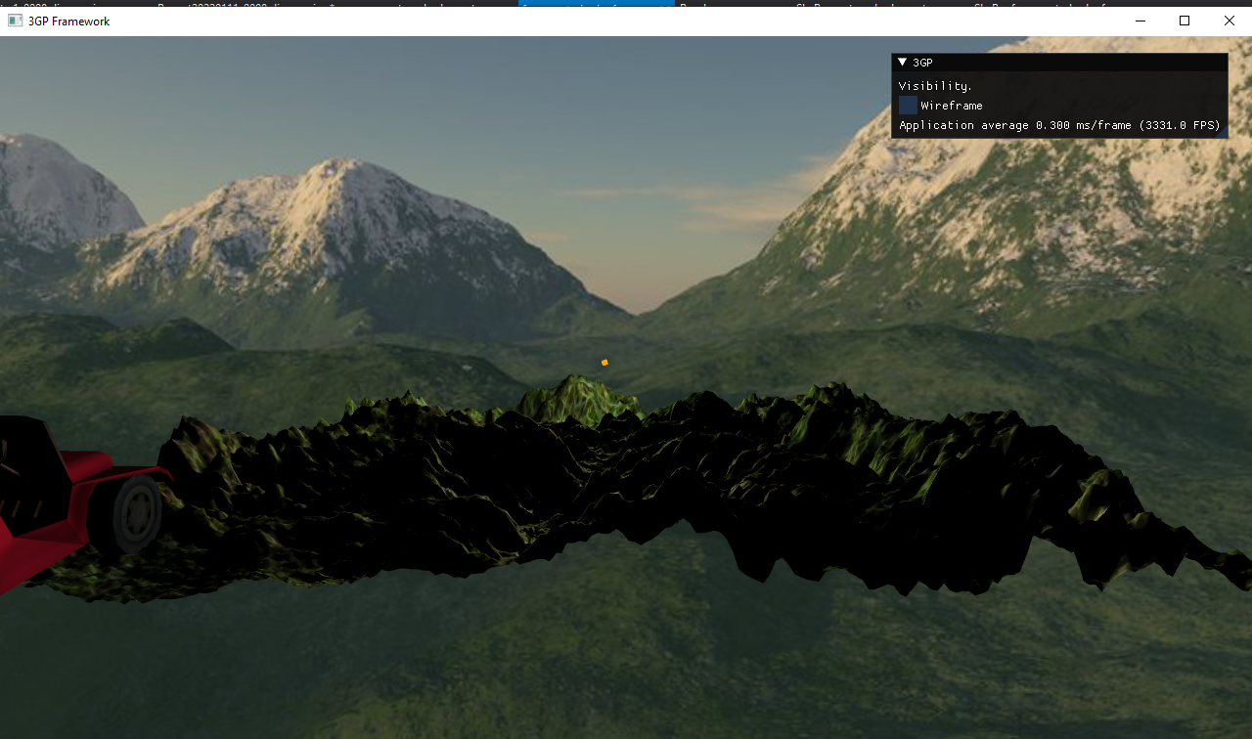

**Cube:**

On my cube I have not added the function to be affected by the light but to be used as the position of the light for reference.

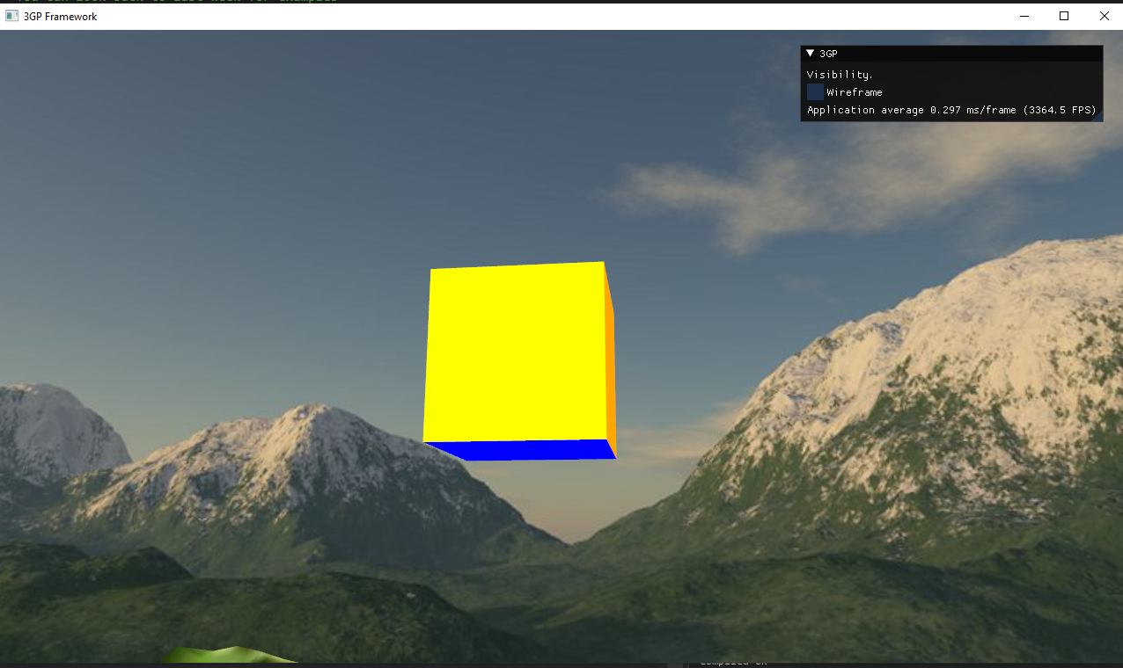

**3D Model:**

I have also added normals to the jeep so that specular light can be seen on it as you move around it.

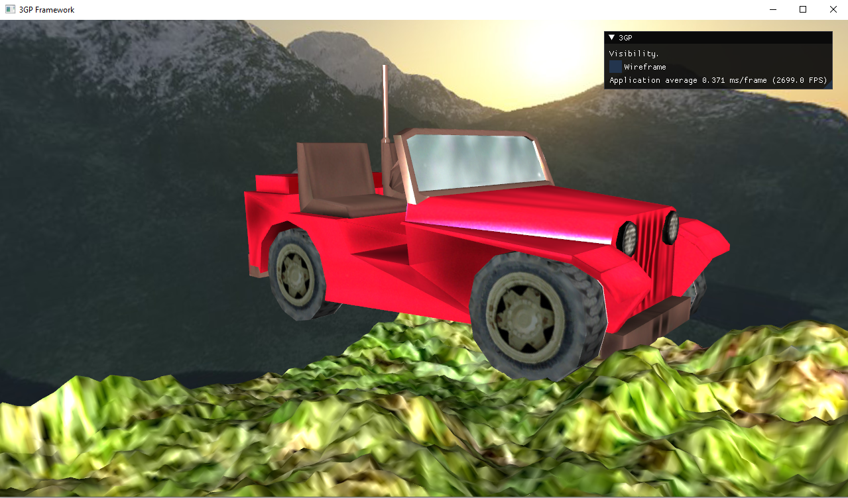

**Skybox:**

I have implemented this skybox with a cube map so all 4 sides are different and you cannot move towards it using similar code to my cube code.

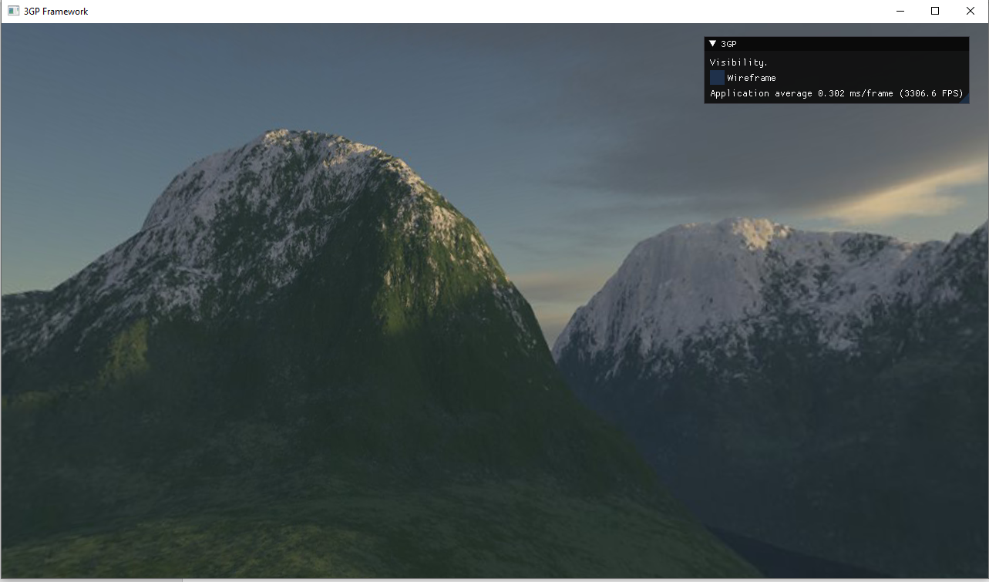

**Wireframe:**

In this I have included a wireframe image of my work.

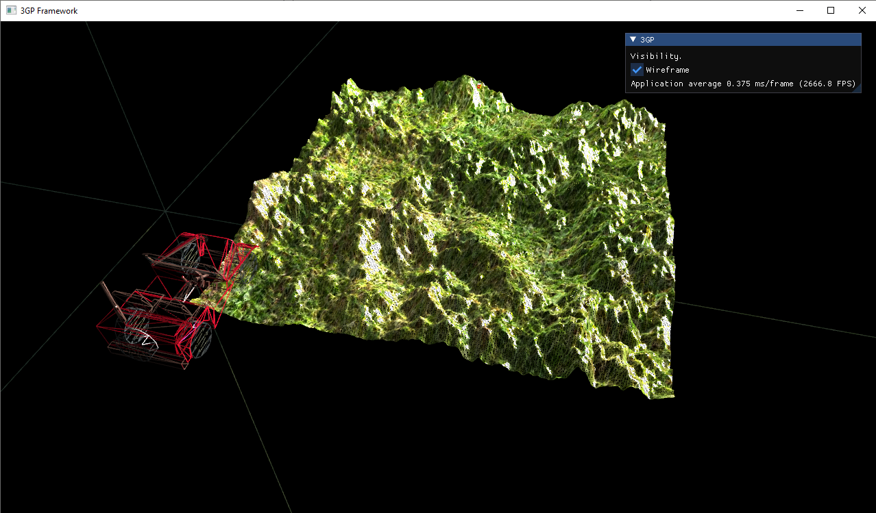

**References:**

Heightmap: <https://www.gamedev.net/articles/programming/graphics/efficient-normal-computations-for-terrain-lighting-in-directx-10-r3313/>

Grass texture: <https://freestocktextures.com/photos-grass/>